**NAME** :- Manish Shashikant Jadhav

**UID** :- 2023301005.

**BRANCH** :- Comps -B. **BRANCH:** B.

**EXPERIMENT 5: To check given string is palindrome or not.**

**SUBJECT** :- CAO (COMPUTER ARCHITECTURE AND ORGANIZATION)

**CODE** :-

data segment  
msg1 db 10,13,"Enter String: $"  
msg2 db 10,13,"It is a palindrome $"  
msg3 db 10,13,"It is not a palindrome $"  
str1 db 50 dup(0)  
data ends  
  
code segment  
assume cs:code, ds:data  
  
start:  
        mov ax, data  
        mov ds, ax  
        lea si, msg1  
        mov ah, 09h  
        int 21h  
        lea si, str1  
        lea di, str1  
        mov ah, 01h  
next:  
        int 21h  
        cmp al,0dh  
        je terminate  
        mov[di], al  
        inc di  
        jmp next  
  
terminate:  
        mov al,"$"  
        mov[di], al  
  
xyz:  
        dec di  
        mov al,[si]  
        cmp[di],al  
        jne notpalin  
        inc si  
        cmp si, si  
        jl xyz  
  
palin:  
        mov ah, 09h  
        lea dx, msg2  
        int 21h  
        jmp last  
  
notpalin:  
        mov ah,09h  
        lea dx, msg3  
        int 21h  
  
last:  
        mov ah, 4ch  
        int 21h  
        code ends  
        end start

**OUTPUT** :-

* String is Palindrome:

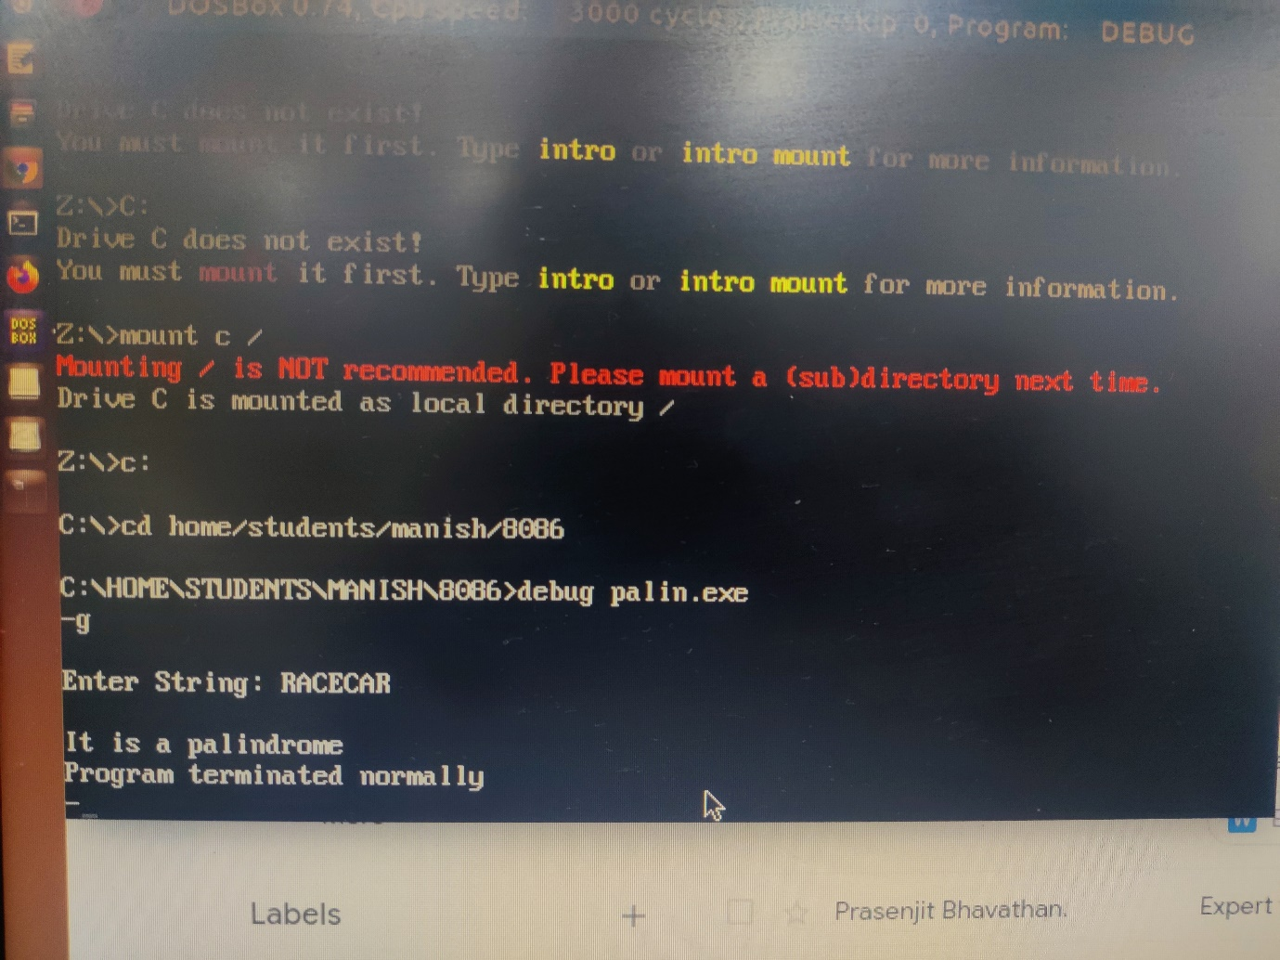

* String is not palindrome:

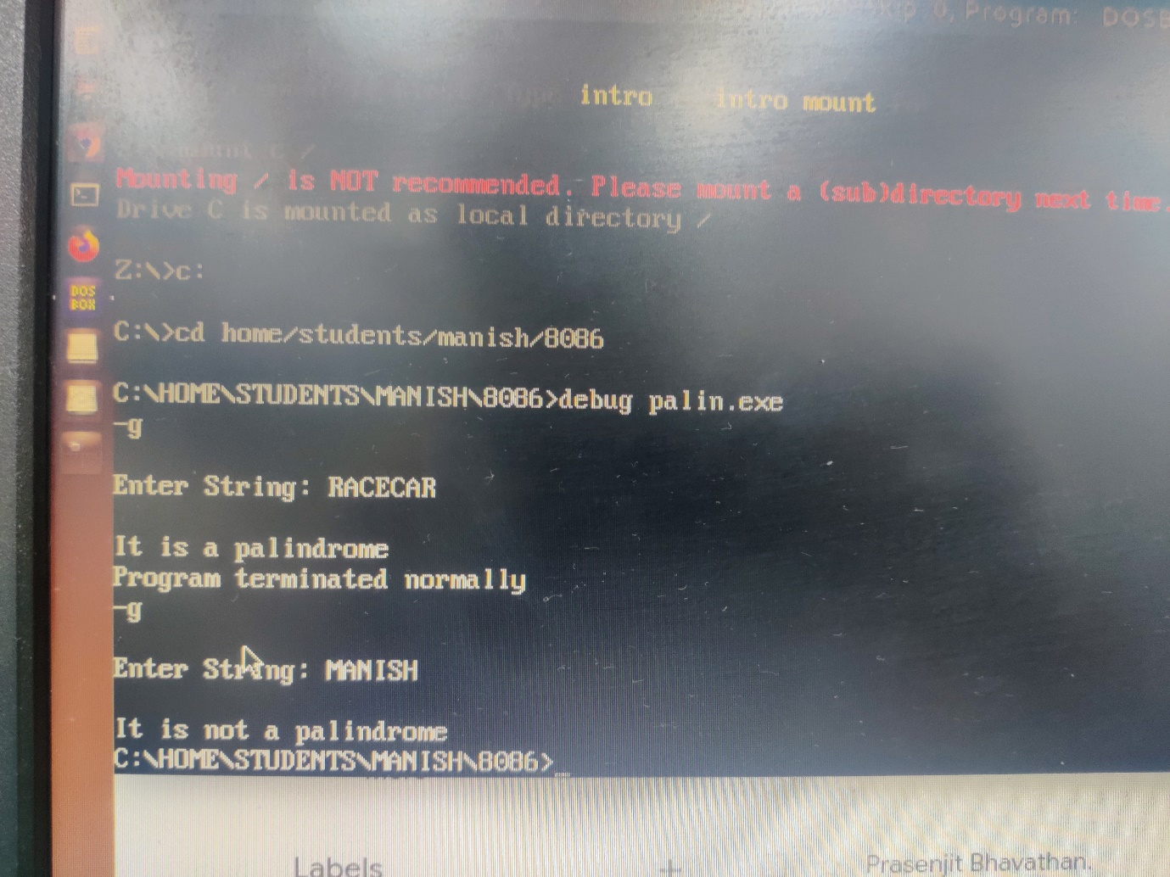

**Conclusion:** Hence by completing this experiment I came to know how to check whether the string is palindrome or not.